**Tower Defence Game Analysis  
Ghusharib Chohan 605**

***The project:***

For my project, I will be creating a tower defence style game. The game will revolve around the storyline of Hansel and Gretel, where they have both escaped the witch but are still stuck in the house, being attacked by the wildlife around them. They, therefore, need to use the candy surrounding the house and the weapons in the house itself to defend themselves from attacks and progress to leave the forest back to their father.

The game will have multiple levels, with each level being harder than the last and will give the user a set number of lives. Once they have lost all their lives, they would have to restart the game. The weapons would need to be purchased using in-game money and this money would be earned by destroying enemies. The weapons would be placed around the house and on the porch etc. and once the user hits play, the rest will be simulated. The attackers will slowly advance and the weapons would fire, reducing their health. If the attacker’s health reaches zero, they die but if they reach the home, the house’s health is reduced. This will be repeated across the levels.

This increasing difficulty and health level means that the game can be simulated to see the effects of the user placing various weapons in certain places. In addition, the interactive part of placing weapons means that it too can be programmed as a click and drag on a screen.

This game is programmable, as it would require a click and drag function to drop weapons in specific places, and a count of all the players’ health and the attackers’ health. In addition, the game will require a loop to simulate the attack and how well the weapons defend Hansel and Gretel. This will also require programmed animations and mathematical calculations, as well as scheduling to progress the game. In addition, file management will be required to save the game and save high scores/keep track of a user’s progress and score.

I will also use a RAD approach to my project as it is the most suitable for it. By creating multiple prototypes and continuously adding functionality, I will be able to gradually improve my game as well as add the complex pieces of code such as scheduling. In addition, this will allow me to break down a fairly complex program into smaller parts which I can program individually and so a Computational Approach is the best way to my project.

***My stakeholders***

The users of my game will target many types of people. Those aged 7 and over who enjoy a strategy game will be constantly attempting levels, while commuters aged above 18 may also enjoy playing the game on their journey to/from work. These users are suitable because the game aims to be a quick and short game with levels of increasing difficulty. It also is a fairly casual game that doesn’t require too much thinking but can keep a user hooked for a fair amount of time, and so is perfect for all ages and all capability.

This project is aimed to give the end user satisfaction of completing the game and enjoyment when they are relatively bored. As it shouldn’t take up too much of the user’s time, it also means that it is a very flexible game and users won’t feel as though they are being forced to play for long hours and can choose how long they wish to play for.

As agreed by those listed, I will be helped by these people in terms of testing etc. as they are a good target market. They are all aged around 17-19 and are regular commuters. This means that they will be willing to play the game for short bursts when they are bored, making them the perfect testing focus group. My group is made of 3 Computer Science Students and 3 General Gamers:

**Michael Kuc** – Being a fellow Computer Science student, he is likely to have a keen idea for the kinds of bugs that could come about when programming such a complex game. This means that he will notice things that others in my focus group may not necessarily pick up.  
**Nathan Wang** – Has a keen eye for the design of menus and screens etc. If he doesn’t feel that something is usable, he will make sure that I know about it and I improve my look and feel of the game (especially in terms of menus)   
**Oliver Wales** – Has a tendency to look out for common bugs and so will notice if there is something that isn’t working quite right in the game (even if it is small)

**Praveen Murugathas** – Generally someone who enjoys playing games and so will be focussed largely on the gameplay and graphics in terms of how well they work together. This should help give me the feedback I need in terms of the mechanics of the game. Praveen is the main user as will give the right feedback in enough detail compared to the other two gamers who will give general feedback.  
**Vinayak Shastri** – Another general gamer who will be focused on the entertainment side of the game  
**Miron Abhayasinghe** – Another general gamer who will give feedback on whether the game is interesting to play or just another regular tower defence

These stakeholders will be able to interact with me through interviews and my blog on [www.ghusharibcomputinggame.wordpress.com](http://www.ghusharibcomputinggame.wordpress.com) .

***Researching the problem***

Firstly, I required some background knowledge into the history of tower defence games and what exactly they are. I did some research online to find such ideas, as there are many forums dedicated to tower defence and other strategy games. In addition, there are many people who have good ideas and post them online in blogs which I thought I could benefit from. My research can be summarised by the points below:

[Source <https://artofgame.wordpress.com/2009/04/14/lets-talk-about-tower-defense/>, Date Accessed [12/09/2017]]

* Tower defence games tend to be endless until failure. This means that I would require my game to have increasing difficulty by itself, and not have a set number of levels.
* It is a strategy game, and strategy needs to be a clear way to win the game when designing it, and so this will require a lot of planning.
* Weapon option is a huge consideration. Having too many can ruin the game, but having too few can make it impossible. Each weapon must be different.
* Surprisingly, few TD games have enemies assaulting the towers, so this could be a key point to add to my own game
* Modifications such as magnets pulling enemies in a certain direction or treadmills aren’t a thing, and these are key things that if added could prove to be a major improvement to a TD game.
* Speeding up the animation (or even slowing it down) is a key feature no tower defence game would be fun without.

[<https://www.gamasutra.com/blogs/LarsDoucet/20140923/226261/Optimizing_Tower_Defense_for_FOCUS_and_THINKING__Defenders_Quest.php>  
Date Accessed [12/09/2017]]

The game may benefit from having a tower offence side of things as well. This is where the user itself is involved in attacking a base strategically rather than only defending the base.

A better way to research this problem is to go for interviews – preferably as individuals. This is because tower defence games are not a new idea, and have been around for many years. They are extremely popular but are beginning to see a downwards trend in activity due to its slightly tedious nature. Therefore, by interviewing people, I should be able to engage with the audience and ask for improvements. This requires question production and arranging interviews.

**My stakeholders responding to the research I did:**



**Questions to ask (Interview 1):**

1. **How much time do you roughly aim to spend on a game/mission?**

This first question is key to understanding what kind of game I need to make. Having missions would give me the benefit of giving my users the ability to play in short bursts, whereas having a long mission might put users off as they don’t like to play a game for that long.

1. **Should the storyline be fully integrated into every part of my game?**

These questions should help me understand whether or not the storyline is the best part of tower defence or if the gameplay is more important. I personally tend to skip storylines, but having a storyline running in the back may help integrate the users more. It is up to the user’s to decide whether they would like a storyline or not, and therefore is an important question in the interview.

1. **Should a mission last longer than a minute, or should there be speed options to help with this.**

Tower defence games were a big craze a few years back but aren’t as popular now. This is due to their repetitive nature and purely because all tower defence games are the same. However, by understanding the user’s reasons for not liking tower defence (if they don’t), then I can adapt my game to overcome their worries.

1. **In terms of graphics, how important would you rate them to be in order to help make the game more addictive?**

The game design is something which is complex to overcome. Some users prefer a professional looking menu and design, others prefer a basic easy to use design. This should help me get a flavour of what the average user likes.

1. **What kind of features are missing from modern day tower defence?**

This is a very general and open question as my earlier research seemed to show that regular tower defence players have great ideas as to how to improve the game. This should help me understand what they want in a game.

1. **Should the power up be one time use only or multiple uses?**

Power ups are liked a lot in other types of games, so by suggesting for them to come into tower defence as well, perhaps I will be creating a different type of tower defence. The number of uses helps understand how to balance the game in this way.

1. **Should the user be allowed to modify their defence during the simulation?**

This is just a general question to ask users whether or not they are happy with the fact that a lot of tower defence games require you to just watch the defence be torn apart during the simulation rather than add to your defence.

***Signing off the Interview Session:***

|  |  |  |
| --- | --- | --- |
| **Interviewee** | **Date/Time** | **Place** |
| Michael Kuc | 15/09/2017 @ 14:20 | Face to Face |
| Nathan Wang | 15/09/2017 @ 14:00 | Face to Face |
| Praveen Murugathas | 14/09/2017 @ 13:30 | Face to Face |
| Oliver Wales | 15/09/2017 @ 14:10 | Face to Face |
| Vinayak Shastri | 18/09/2017 @ 13:30 | Face to Face |
| Miron Abhayasinghe | 18/09/2017 @ 13:40 | Face to Face |

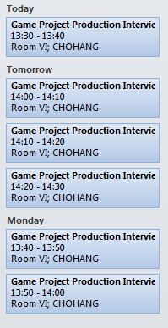

I attended and answered all the questions in my interview session 1 on the date stated:

From the answers I gathered from interviewing (See Appendix A), these were the key points which I decided to take forward as part of my research into a solution:

* Users tend to play tower defence for around 30 minutes up to 45 minutes during one sitting meaning that it should be possible to avoid having levels and instead, a never ending game
* Most users decided that storylines were an important feature as they helped explain the game, but in a tower defence game, an intro alone will do
* Tower defence games can become repetitive, and this is especially a problem when there is one clear strategy that can power you through all the missions
* The design should be simple and the menus should match with the graphics
* Common Features requested – Building Times, Emergency feature when the game is getting tough such as Spikes from Bloons
* Objectives, More than One Route, Enemies Fight Back
* Powerups would be nice, especially the Spikes feature from Bloons and other emergency powerups, but these should be limited to enable a balance to be reached. This should be done via reset times etc.
* Some people thought that yes, you should be allowed to add to your defence while the simulation is running whereas others disagreed. However, it is probably important to have an additional defence to enable the powerup features. Once again, this should not ruin the balance of the game.

I looked at other tower defence games to get ideas from them too, as my interviews referred me to games users liked such as Bloons. This gave me an idea of the look and feel of the game I should be aiming for in my own game:

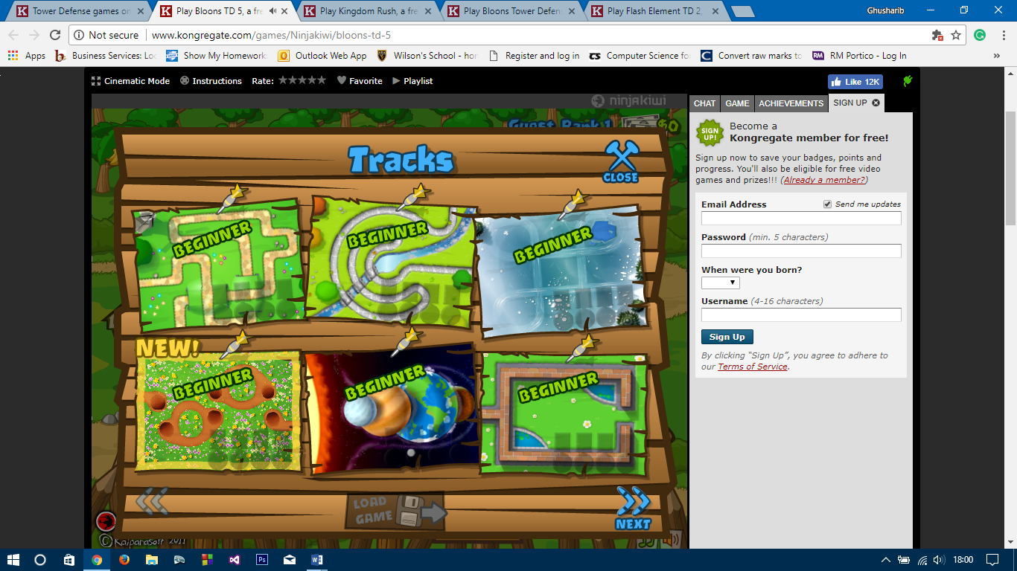

Bloons TD5 offers  
 multiple tracks to play on  
 from the start

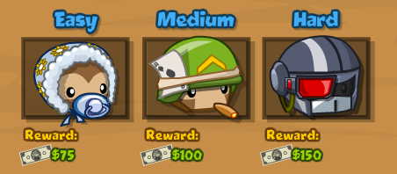  
  
  
  
  
It also allows you to choose a difficulty level with different in game money rewards

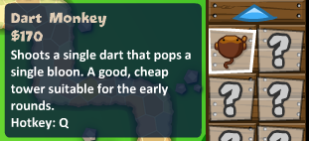A complete description of each defence option is given along with their abilities. It also offers hotkeys for quick detonation

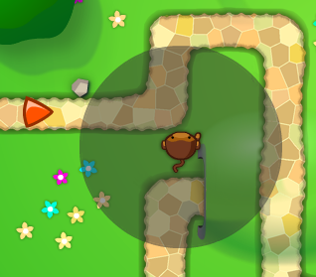

In addition, upon placement, you are shown the range of the defence, which helps a lot with the gameplay

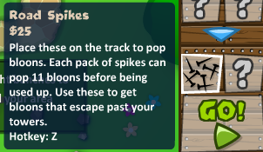  
  
  
An upgrade bar on the bottom allows you to extend the range of the defenders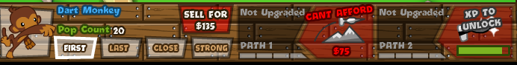 or increase the damage they cause  
  
These are the famous spikes which were very popular in my interviews. However, they are really cheap and mean that they make the game too easy. It is better to have a high cost to deter use for emergencies only.

  
There is information on the next wave of attackers to help the user in planning their defence

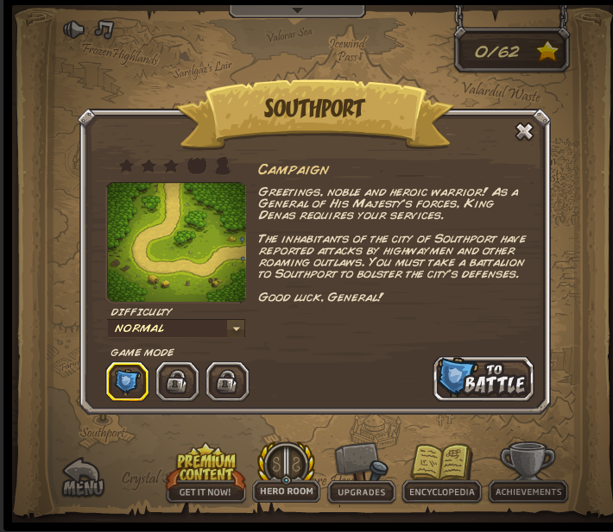Kingdom Rush TD has a very good storyline to follow. It explains the entire story behind why towers are being defended and tend to be popular when the story is very interesting.

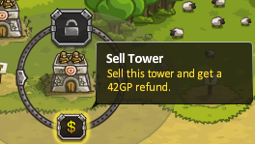

You are also often offered the chance to sell your tower in order to gain money and then buy a better one in its place.

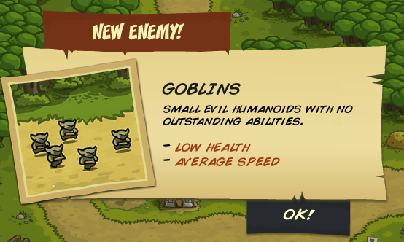

Enemies also have information on them which is shown to the user to help them with their defence.

**Researching on Wikipedia**[https://en.wikipedia.org/wiki/Tower_defense, Accessed 12/09/2017]

*“The basic gameplay elements of tower defence are:*

* *territories or possessions (or collectively the "base") that must be defended by the player*
* *the base must survive waves of multiple incoming "enemy" attacks*
* *placement of "Tower" elements, or obstructions along the path of attacking enemies”*

*“Some features of modern tower defence:*

* *Player placed obstructions that can damage or kill enemy attackers before destroying the base*
* *Ability to repair obstructions*
* *Ability to upgrade obstructions*
* *Some sort of currency with which to purchase upgrades and repairs (this can be time, in game currency or experience points, such as being earned by the defeat of an attacking unit*
* *Enemies capable of traversing multiple paths*
* *Each wave usually has a set number and types of enemies”*

According to this Wikipedia article, Tower Defence games don’t tend to be real time but rather be turn based, whereby you have a build, defend and repair stage. This suggests that tower defence games tend to have a set structure that they follow which should also be implemented as part of my game

***Problem Specification***

The following features will be important in order to create a good tower defence game:

* *The game should be endless until failure*. The reason for this is that during my related games research, I found that games with levels weren’t as fun as games without as you would have just begun engaging fully with the game when all of a sudden, the level would be over and you had to start again. By having an endless game, you have the ability to add to your initial setup and progressively improve your defence as the game gets harder with tougher enemies and of a greater quantity.
* *It is necessary for the game simulation to be slowed down or speeded up at times.* This will avoid the user getting bored as they will be able to speed up the game when they feel as though they should be able to win. In addition, it allows careful placement of weapons by slowing down the game and adding weapons as soon as they are needed (or to add emergency weapons). The speed dial was a common feature on most tower defence games.
* *There needs to be a significant increase in difficulty as you progress through the game.* This can come through tougher enemies or more enemies attacking in one wave. My interviews and research showed me that tower defence games fail to entertain when you can power through missions with the same strategy throughout. There needs to be enough discouragement of buying excessive weaponry and a decent increase in difficulty throughout the game for the game to be considered good.
* *Building times need to be implemented.* This is a common feature in tower defence games (although not all games use it) and should help to aid with the balance of the game, avoiding the game being too easy to complete. It was also requested by my interviewees and so overall should be very helpful to add into the game.
* *Emergency Powerups need to be included.* This is to help users during the game in case of the defence not being sufficient, but should have a high enough cost to deter the user from using it.
* *Health bars, information on weapons, ranges of weapons, upgrades of weapons and selling weapons* are all common features that a tower defence game would be incomplete without. This helps make the game a strategy game and aids the user in making their decisions throughout the game. It is therefore essential to have these.
* *There will need to be an in-game currency system and scoring system.* This is used to buy weapons to create a tougher defence and to give the user an incentive to score more points.
* *There needs to be a save file showing all the high scores on the user’s PC.* This adds a competitive edge to the game as users will compete to get a greater score than each other. This is a feature not all tower defence games have even though it would prove popular with all users.
* *There needs to be a button to start the attack so that users can prepare beforehand.* This is essential as it is a strategy game and the user must be prepared before the attack starts. Therefore, by having a button to say they are ready for the attack, they are able to create a defence and start playing when they are ready.
* *Menus and clear instructions need to be present.* This enables the user to understand how they need to play the game and where they can find the right information. These menus may need to lead to information on high scores, enemies, weapons etc. as well as any other help the user may require (and of course a button to begin playing a new game). This is essential in all games otherwise the user may not know what to do.
* *Information about the next wave of attackers.* This is available in all good tower defence games and is an important aspect of tower defence. This is because tower defence in general is a strategy related game, and the best way to get the user to use various strategies is to tell them what is coming up next. They can therefore adjust and improve their defence accordingly and be prepared for when they come.

Optional additions include:

* *Storyline –* These help add to the game but are not essential as not everyone reads the storyline. In this game, only an intro should be required as the game is endless.
* *Good clean design with decent graphics –* This was requested in the interviews but was not ranked as highly needed as the other essential features.
* *A variety of maps.* This makes the game more interesting but is not essential as many good games can be created with just a single map. This is something that was asked for in the interviews, but should only be added after the rest of the game has been implemented fully.
* *Hotkeys.* Hotkeys aren’t used a lot but are a feature I thought should be absolutely essential in tower defence games. For those who play a lot of tower defence, they may seek to learn a quicker way of deploying weapons, and hotkeys allows them to do that. This will help improve my game but again is not an essential feature.

**My stakeholders reading and agreeing to the problem specification outlined above:**

***Signing off the Proposed Solution Specification:***

*I, the named stakeholder of this tower defence game, agree and accept the features stated in the proposed solution specification above.*

|  |  |
| --- | --- |
| **Miron Abhayasinghe** | **_______________________________** |
| **Michael Kuc** | **_______________________________** |
| **Praveen Murugathas** | **_______________________________** |
| **Vinayak Shastri** | **_______________________________** |
| **Oliver Wales** | **_______________________________** |
| **Nathan Wang** | **_______________________________** |
|  |  |

**Updates to the original specification**

My stakeholders had now agreed to the proposed problem specification, and so I was at a stage to continue with my project. However, I first decided to review the problem specification one last time and I came across a few parts within it which I did not think should have been part of the final specification. This meant that I had to edit my problem specification once more and create a new and improved specification.

There was nothing more that needed to be added but a few features had to be removed. These were as follows:

* Telling which enemies are to come in the next wave is a bit pointless for the game. This is because the game enemies are going to be randomly generated at run time and there is no guarantee of what will come next. This randomness is the unique feature of my game and so by telling the user what is to come next, I will be inadvertently removing my main feature. In addition, when the enemies do come, users should be easily able to see what enemy is coming next without the need for some text.
* The game is endless until failure, so building times are useless. This is because after each wave, the user gets the chance to add to their defence and cannot add anything else during the runtime of the game. If the user was allowed to add weapons during runtime, it would have been useful to have building times to avoid misuse of the feature. Therefore, this feature should be removed to avoid contradicting other more essential features.
* Difficulty will instead be increased by increasing speed as this also helps keep the game fun as users don’t need to wait longer periods of time as the game progresses.

***Problem Specification 2nd Draft***

The following features will be important in order to create a good tower defence game:

* *The game should be endless until failure*. The reason for this is that during my related games research, I found that games with levels weren’t as fun as games without as you would have just begun engaging fully with the game when all of a sudden, the level would be over and you had to start again. By having an endless game, you have the ability to add to your initial setup and progressively improve your defence as the game gets harder with tougher enemies and of a greater quantity.
* *It is necessary for the game simulation to be slowed down or speeded up at times.* This will avoid the user getting bored as they will be able to speed up the game when they feel as though they should be able to win. In addition, it allows careful placement of weapons by slowing down the game and adding weapons as soon as they are needed (or to add emergency weapons). The speed dial was a common feature on most tower defence games.
* *There needs to be a significant increase in difficulty as you progress through the game.* This can come through tougher enemies or more enemies attacking in one wave. My interviews and research showed me that tower defence games fail to entertain when you can power through missions with the same strategy throughout. There needs to be enough discouragement of buying excessive weaponry and a decent increase in difficulty throughout the game for the game to be considered good. In addition, the enemies will exponentially speed up as the game progresses.
* *Emergency Powerups need to be included.* The power up should only be allowed to be used once and will kill all enemies on screen when used.
* *Health bars, information on weapons, ranges of weapons, upgrades of weapons and selling weapons* are all common features that a tower defence game would be incomplete without. This helps make the game a strategy game and aids the user in making their decisions throughout the game. It is therefore essential to have these.
* *There will need to be an in-game currency system and scoring system.* This is used to buy weapons to create a tougher defence and to give the user an incentive to score more points.
* *There needs to be a high scores file on the user’s PC.* This adds a competitive edge to the game as users will compete to get a greater score than each other. This is a feature not all tower defence games have even though it would prove popular with all users.
* *There needs to be a button to start the attack so that users can prepare beforehand.* This is essential as it is a strategy game and the user must be prepared before the attack starts. Therefore, by having a button to say they are ready for the attack, they are able to create a defence and start playing when they are ready.
* *Menus and clear instructions need to be present.* This enables the user to understand how they need to play the game and where they can find the right information. These menus may need to lead to information on high scores, enemies, weapons etc. as well as any other help the user may require (and of course a button to begin playing a new game). This is essential in all games otherwise the user may not know what to do.

Optional additions include:

* *Storyline –* These help add to the game but are not essential as not everyone reads the storyline. In this game, only an intro should be required as the game is endless.
* *Good clean design with decent graphics –* This was requested in the interviews but was not ranked as highly needed as the other essential features.
* *A variety of maps.* This makes the game more interesting but is not essential as many good games can be created with just a single map. This is something that was asked for in the interviews, but should only be added after the rest of the game has been implemented fully.
* *Hotkeys.* Hotkeys aren’t used a lot but are a feature I thought should be absolutely essential in tower defence games. For those who play a lot of tower defence, they may seek to learn a quicker way of deploying weapons, and hotkeys allows them to do that. This will help improve my game but again is not an essential feature.

Obviously, some features of the game have therefore had to be removed, and these are as follows:

* Nathan mentioned how silly telling the user the enemies that will be coming in the next wave is. Therefore, there is no longer a bar along the bottom of the game screen which shows which enemies will be coming up in the next wave, but instead the user will be able to see the enemies using their own eyes
* Building times are an unessential feature. Seeing as the game is endless until failure and you are not allowed to add weapons during the game simulation, building times are irrelevant. Therefore, there will be no building times in the final game.
* Difficulty will now be increased through slowly increasing enemy speed in addition to the previous method. This is because otherwise, a user may be able to find a weapon setup which kills all enemies every single time making the game not as fun to play.

**Stakeholder response:**

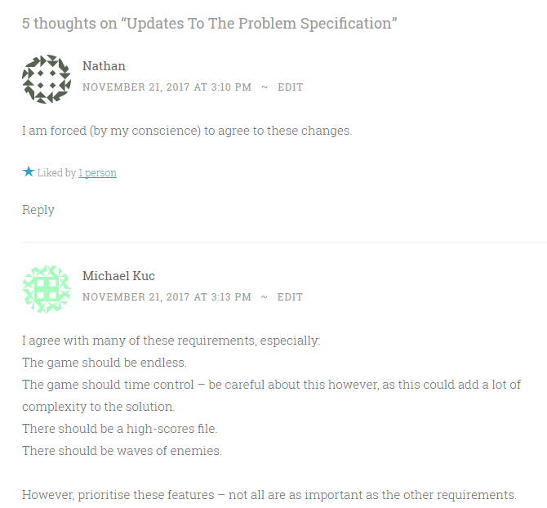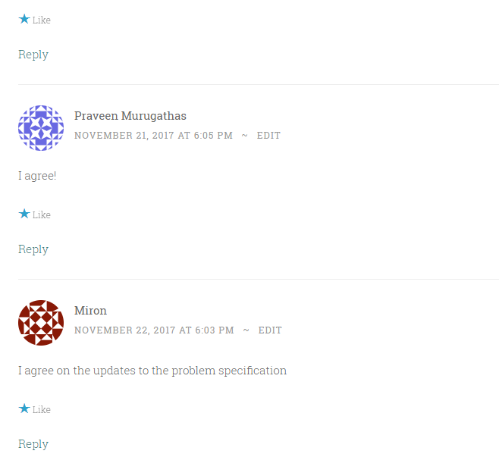

***Limitations of the game***

The proposed solution is not perfect, and there are some parts of the solution which means that a game suitable for the entire market is not being created.

1. Each tower defence game player has different specifications which they want, which is impossible to have in the same game. For example, while one user prefers levels in a game, anther prefers the game to be an endless type of game. This means that not all of my users will be 100% satisfied with the game as it doesn’t completely suit their needs. However, as it is only possible to have one kind of game – levelled or endless – this is a limitation of my solution.
2. The proposed solution is a very big task to handle in a short amount of time. Though most of my key features should be covered in the time given, it will be very difficult to add other important features which quite often influence a user’s decision to play a game in the first place. Graphics are key, but they take a lot of time to develop, and so this may mean that the game is not as popular as other games. However, I may be able to overcome this problem by making it a “simplistic” game which has “ok” graphics which works well with the casual user. This does depend on how much time I have left at the end of the implementation.
3. Tower defence games struggle the most with balance. The games tend to have a clear strategy to win the game and have the ability to power through all the levels without a problem. This could be a problem I have in my game as well, or I could even end up making the game too difficult to complete.

***Software and Hardware Configurations:***

The game should be able to run on most modern computers and laptops, and will be designed for any Operating System after and including Windows 7. There should be at least 1GB of RAM to run the operations of the game, and have around 200MB worth of free disk space. There are no other major requirements, but the game will not necessarily be limited to these specifications.

In terms of software, the computer will need to be able to run C++ and the SFML libraries which should come included with the software and with the operating system (given that it is a Windows Operating System).

***Success Criteria for my game:***

1. The game needs to be entertaining. Users should be able to play for the times they have stated in their interviews (an average of half an hour) and not get bored in that duration. If they feel as though the game is being repetitive and is not allowing them to engage too well, it is not a good tower defence game. Therefore, this is an important factor in determining whether or not the game is successful. I should expect users to play for about 15-30 minutes based on the research I have carried out.
2. The game should run fairly smoothly. It isn’t too uncommon for games to lag a little during run time, but normally these aren’t too visible. If in the duration of a gameplay there is significant lag, it might be deemed a failure. For the programming of the game to be considered successful, the game should run smoothly which will reflect efficiency in code, and so this is a good factor.
3. Users should feel that their issues in terms of the problems usually faced in tower defence problems have been addressed. The biggest problem needs to be that users should not be able to power through all the levels and equally not be facing excessive difficulty. They will need to be quizzed on the “balance” of this tower defence game. The balance of the tower defence game cropped up in my interview session time and time again and so will be an important factor in determining the success of my game.